AUTOMATED DOCTOR APPOINTMENT MANAGEMENT SYSTEM FOR MEDICAL DOMAIN IN SINHALA USER(ADAMS).
2020-175

Project Proposal Report

D.D.S. Rajapakshe

B.Sc. (Hons) Degree in Information Technology

Department of Information Technology

Sri Lanka Institute of Information Technology
Sri Lanka

March 2020
DETERMINE THE OPTIMUM IDENTIFICATION TO SORT OUT THE HUMAN DISEASES (PATIENT IS GIVEN).
2020-175

Project Proposal Report

D.D.S. Rajapakshe

B.Sc. (Hons) Degree in Information Technology

Department of Information Technology

Sri Lanka Institute of Information Technology
Sri Lanka

March 2020

DECLARATION

We declare that this is our own work and this proposal does not incorporate without acknowledgement of any material previously submitted for a degree or diploma in any other university or Institute of higher learning and to the best of our knowledge and belief it does not contain any material previously published or written by another person except where the acknowledgement is made in the text.

Name | IT Number | Signature | Date
D.D.S Rajapakshe | IT16234062 |  | 25/02/2020

Supervisor
------------------------------------------------------ ---------------------------
Prof. Koliya Pulasinghe Date

Co-Supervisor
------------------------------------------------------ ---------------------------
Ms. Vijani Piyawardana Date

ABSTRACT

In Sri Lankan medical systems are in the English language (Doc990, e-Channelling PLC) and majority of the Sri Lankan cannot understand the English terms (According to 2012 Department of Census and Statistics server (DCS)) and they do not possess user experience about the web Information system. the majority medical information systems are now looking forward to the automated Sinhala conversation system to help the customers (patients) to make a decision on their health issues. HCL is the majority suitable method to interact with humans and machines. Developing with NLP system, it can satisfy users. According to DCS survey 70.5 percent of those using the internet had connected through their smartphone or tablet in the first half of 2018, up from 59 percent a year earlier, while 27.1 percent used a desktop or laptop, down from 38.1 percent [1]. Thus, the majority suitable Human interaction method in Sri Lanka is a mobile application.
The main objective of this system is developing an Automated Doctor Appointment Management System for medical domain in Sinhala user (ADAMS). and as a sub-objective, Determine the Optimum Identification to sort out Human Diseases (The Patient is a given) is one of the ones (DOI-HD). Most of the people doesn’t have clear idea about their unwellness. As core objective is to use a huge Owlready Knowledge Base using a sort out a human unwellness by DOI-HD. There for design OWL rules for the ontology will help determine the optimum identification to sort out Human Diseases. Developing a User Voice Processing (UVP) system will Analyse a Sinhala voice command of the patient. The system is converted user voice to Sinhala text.
This document presents a survey, starting from the literature review, Ontology architecture, evaluation methods/criteria, comparison of evaluation methods, Project requirements and Budget Justification.

Keywords -: SWRL, Protégé, NLP, AI, Ontology, STT,

TABLE OF CONTENTS
DECLARATION i
ABSTRACT ii
LIST OF FIGURES iii
LIST OF TABLES iii
LIST OF ABBREVIATIONS iv
1 INTRODUCTION 1
1.1 Background & Literature Survey. 1
1.1.1 Background. 1
1.1.2 Literature Survey. 2
1.2 Research Gap. 6
2 RESEARCH PROBLEM 7
3 OBJECTIVES 7
3.1 Main Objectives 7
3.2 Specific Objectives 8
4 METHODOLOGY 9
5 DESCRIPTION OF PERSONAL AND FACILITIES 10
6 PROJECT REQUIREMENTS 11
7 WORK BREAKDOWN STRUCTURE 12
8 BUDGET AND BUDGET JUSTIFICATION 13
9 TIME PLAN 15
10 REFERENCES 16

LIST OF FIGURES

Figure 0.1: High level architecture diagram for DOI-HD 9
Figure 9.1: Requirements Engineering Process 11
Figure 10.1: Work breakdown structure 12
Figure 12.1 : Gantt Chart 15

LIST OF TABLES

Table 4-1 : Research Gap 6
Table 8-1 : Description of personal 10
Table 11-1: Budget 14

LIST OF ABBREVIATIONS

ADAMS : Automated Doctor Appointment Management System 4, 7
CDS : Clinical Decision Support 7
DOI-HD : Determine the Optimum Identification to sort out Human Diseases 4, 7, 13
EHR : Electronic Health Record 7
EMR : Electronic Medical Record 7
GO : Gene Ontology 8
HTK : Hidden Markov Model Toolkit 10
MIS : Management information system 6, 7, 8
MPI : Master Patient Index 7
NLM : National Library of Medicine 9
OWL : Web Ontology Language 8, 10
RPM : Remote Patient Monito 7
RS : Rule Selector 9
STT : Surface Tension Transfer 4, 7
SWRL : Semantic web Rule Language 4, 8, 9, 15
UMLS : Unified Medical Language System 8, 9, 14
UMLS-SN : UMLS Semantic Network 8
UVP : Developing a User Voice Processing 4, 7
WSN : Wireless sensor network 8

INTRODUCTION

DOI-HD and UVP systems are key part of the ADAMS. The open new E-health information system and researcher’s area are integrating various health information domains into Project. DOI-HD is a that type of project and used to Identified a Human disease. Developing DOI-HD used the Ontology theorem to integrating health information domains and used to domain specification of a conceptualization. The system is capably catch user disease. UVP use to process a user voice and core objective are understanding a user Sinhala voice and user validation.

Background & Literature Survey.

Background.

The Internet is a huge platform for people to use and communicate with each other. It is the global lattice of governments, companies, organizations, individual units of networks and so on. Became a few years, the internet has become a universal and common source of information for people globally. It has delineated business communication in new ways and, in the past few years, social media platforms and mobile phones have changed the way people use the Internet. Modern busy lifestyles, people are trying to use their time is effective. Therefore, most of the people are looking for an online-based service. As a DSC survey, 70.5 percent of those using the internet have connected through their smartphone or tablet.
In the last 10 years or so, the application of ontology in the information system as a shared platform for information integration and retrieval application. MIS(medical information systems) is used in medical domain applications [2]. One of the medical industry-based online IT solutions is an E-health information system. The E-health information systems are Electronic Medical Record (EMR), Electronic Health Record (EHR), Practice Management Software, Master Patient Index (MPI), Patient Portals, Remote Patient Monitoring (RPM) and Clinical Decision Support (CDS) [3].
DOI-HD is a CDS E-health information system and its base on an Ontology MIS. Clinical decision support systems analyze data from various clinical and administrative systems to help healthcare providers make clinical decisions [4]. The data can help prepare diagnoses or predict medical events-such as drug interactions [4]. These tools filter data and information to help clinicians care for individual patients [4]. A DOI-HD system has the ability to identify a human’s disease.
UVP is used to get user response in the system. UVP convert to Sinhala user voice into Sinhala Text and user validation. Most famous real-world STT programable examples are Google Speech text API and Mozilla deep speeches. Google Speech text API is available for the Sinhala language, but Mozilla deep speeches don’t the accuracy of Sinhala Language and those are opensource.
In a world where the industry of mobile applications is continuously expanding and new health care apps and devices are created every day, it is important to take special care of the collection and treatment of users’ personal health information [5]. However, the appropriate methods to do this are not usually taken into account by apps designers and insecure applications are released [5]. Disclosures of his or her identifiable health data are going to be damaged by the user as a company. Therefore, protecting user sensitive data user validation is most important and those methods are mostly used in a mobile app Ex: Email verification, Face recognition and Image Encryption.

Literature Survey.

- Ontology-driven semantic profiling and retrieval in medical information systems [6].

This paper presents a OntoMOVE Framework –‘Ontologies on the MOVE’ – that combines the use of ontology driven annotations and the application of a novel sub-ontology extraction methodology (called MOVE) for achieving interoperability and improving the effectiveness of information retrieval for the specific MIS domain [6]. It is extracting a sub-ontology that meets the user requirements and is based on the Unified Medical Language System(UMLS) knowledge sources(User Recode Ex: patient records, administrative health data, bibliographic), namely the UMLS Santic Network (UMLS-SN) and UMLS Metthesaurus [6]. The methodology of sub-ontology based semantic requirement profiling and information retrieval is generally applicable in any domain where it is possible to annotate resource-sets [6]. Designed OntoMOVE to be specifically applied in the medical information systems domain [6].

- Owlready: Ontology-oriented programming in Python with automatic classiﬁcation and high-level constructs for biomedical ontologies [7].

Research output is to design a tool for accessing easily the entities of an OWL ontology, with high-level constructs helping with biomedical ontologies [7]. The ontologies rely on the open-world assumption, whereas the medical reasoning must consider only evidence-based medical knowledge as true [7]. They designed a Python module for ontology-oriented programming [7]. It allows access to the entities of an OWL ontology as if they were objects in the programming language. They propose a simple high-level syntax for managing classes and the associated “role-ﬁller” constraints [7]. They also propose an algorithm for performing local closed world reasoning in simple situations [7]. They developed Owlready, a Python module for high-level access to OWL ontologies [7]. The paper describes the architecture and the syntax of the module version 2 [7]. It details how they integrated the OWL ontology model with the Python object model [7]. The paper provides examples based on Gene Ontology (GO) [7]. We also demonstrate the interest of Owlready in a use case focused on the automatic comparison of the contraindications of several drugs [7]. This use case illustrates the use of the speciﬁc syntax proposed for manipulating classes and for performing local closed-world reasoning [7]. Owlready is an Open-Source software.

- Applying Ontology to WBAN for mobile applications in the context of sport exercises [8].

This paper details a new mobile application for runners that calculates the burned calories based on a dedicated ontology [8]. Some of the main goals for using this ontology are interoperability management, the ease of information management and the minimization of the battery consumption of the mobile device by requiring less network resources and data processing due to the use of ontologies [8]. They used WSN generic ontology [8].
Application, they are used the Protégé 4.3 for defining the ontology model and the Jena API for implementing the ontology on the mobile application and the server [8]. Jena API is the Semantic Web framework for Java. Rules are added to the ontology using Semantic web Rule Language SWRL [8]. The Pellet reasoner is used in order to extract inferred information from the ontology [8]. SPARQL is dedicated to querying knowledge from the ontology [8].

- The Unified Medical Language System(UMLS):integrating biomedical terminology [9].
Research projects such as TAMBIS [10] have addressed the specific issue of integrating disparate resources for bioinformatics through a model of domain knowledge [9]. While TAMBIS [10] provides a framework for integrating resources, its coverage is currently limited to five sources [9]. In this paper, they present a different approach to information integration through terminology integration [9]. The Unified Medical Language System (UMLS), developed over more than 15 years, which covers the entire biomedical domain [9]. The UMLS was developed by the National Library of Medicine (NLM) as ‘an effort to overcome two significant barriers to effective retrieval of machine-readable information’ the variety of names used to express the same concept and the absence of a standard format for distributing terminologies [9]. By integrating more than 60 families of biomedical vocabularies, the UMLS Metathesaurus currently provides not only an extensive list of names (2.5 million) for its 900 551 concepts but also over 12 million relations among these concepts [9]. Its scope is broader and its granularity finer than that of any of its source vocabularies [9].

- SWRL rule-selection methodology for ontology interoperability [11].

In this paper, they focus on improving the performance of queries addressed over ontology alignments expressed through SWRL rules [11]. Indeed, when considering the context of executing queries over complex and numerous alignments, the number of SWRL rules highly impacts the query execution time [11]. Moreover, when hybrid or backward chaining the reasoning is applied, the query execution time may grow exponentially [11]. Still, the reasoners involved deliver performant results (in terms of execution time) when applied over reduced and simpler rule sets [11]. Based on this statement, and to address the issue of improving the query execution time, they describe a novel approach that allows, for a given query, to ignore unnecessary rules [11]. The proposed Rule Selector (RS) is a middleware between the considered systems and the reasoner present on the triple store side [11]. This paper is summarized as follows [11].
- They describe their approach for improving the performances of queries addressed over ontology alignments described in terms of SWRL rules [11].
- They define a novel architecture for our rule selector (RS), architecture that contains two main modules [11].
  - The Rule Pre-processing module is responsible for transforming existing SWRL rules describing the ontology alignment into canonical rules [11]. In other words, this module performs a normalization of the existing ruleset [11].
  - The Query execution module aims at 2 goals [11].
    - Identify the necessary and sufficient rule subset that allows answering a given query [11].
    - Eventually, remove rules from the previously identified rule set (step 2.b.i) that produce rule cycles (e.g. A → B → A) [11].
- They specify the algorithms used by the two previously described modules(Their own Algorithm) [11].
  - Algorithm for the Rule Pre-processing module [11].
  - Algorithm for the Query execution module [11].
- They provide an evaluation of the performance of their approach, by applying 4 different queries over an alignment of 2 ontologies [11]. Moreover, they compare their approach with existing ones [11].

- Ontology-Oriented Programming for Biomedical Informatics [12].

The research project presenting information about new drugs to physicians [12]. To guarantee independent information, this information is produced automatically by comparing the new drug to the older ones, using criteria such as efficacy in clinical trials, contraindications, and known adverse effects [12]. The automatic comparison of drug properties like contraindications is not easy because contraindications are often expressed at different levels of granularity in drug databases, therefore they designed an ontology of contraindications [12]. They were experienced difficulties in connecting the ontology to the database and the website, and more generally to manipulate the ontology in the computer program [12]. They are a reflection about methods for accessing ontologies, and to the development of OwlReady [12], a Python 3 module for ontology-oriented programming with full class-support, including dynamic class creation and classification of classes at run time using the HermiT OWL reasoner [12]. OwlReady supports OWL 2.0 [12]. An experimental feature allows them to automatically generate dialog boxes for editing individuals and classes in ontology [12]. Populating the ontology from the results of SQL requests, calling the reasoner, and generating HTML pages from the ontology was easy, from a computer-science point of view [12]. The automatic generation of dialog boxes was very convenient, it allowed them to modify the ontology without having to manually update the editing interface [12]. The computation time of ontology-oriented programming with OwlReady and Python was higher than a traditional API in Java [12]. However, the difference is insignificant compared to the time consumed by the HermiT OWL reasoner, or the time they gained during software development (shorter source code implies faster development) [12].

- Continuous Sinhala Speech Recognizer [13].

The objective of this research was to apply existing continuous speech recognition mechanisms to develop a continuous Sinhala speech recognizer, which is not bound to any specific domain [13]. The building of an ASR system mainly consists of designing two models, namely the Acoustic Model and the Language Model [13]. The Acoustic model is responsible for detecting phonemes which were spoken, and the Language Model is responsible for detecting connections between words in a sentence [13]. The implementation of the ASR using Hidden Markov Model Toolkit (HTK) which was developed by Cambridge University, UK (Young et al, 2006) [13]. HTK is primarily designed for speech recognition using Hidden Markov Models (HMMs) [13].

- Diabot: A Predictive Medical Chatbot using Ensemble Learning [14].

The paper presents a state-of-the-art Diabot design with an undemanding front-end interface for a common man using React UI, RASA NLU based text preprocessing, quantitative performance comparison of machine learning algorithms as standalone classifiers and combining them all in a majority voting ensemble [14]. It is observed that the chatbot is able to interact seamlessly with all patients based on the symptoms sought [14]. The accuracy of the Ensemble model is balanced for general health prediction and highest for diabetes prediction among all weak learners considered which provides motivation for further exploring ensemble techniques in this domain [14]. At a high level, the system consists of a front-end User Interface(UI) for the patient to chat with the bot [14]. It is a developed using react UI platform which uses HTML and JavaScript [14]. The chatbot communicates with the NLU engine at the backend via API calls [14]. The NLU engine is developed using RASA NLU platform [14]. Two models- one for generic health prediction and another for advanced diabetes prediction are trained at the backend using the general health dataset and the Pima Indian diabetes dataset which provides the necessary diagnosis decision to the NLU engine which is trained to provide an output based on user queries [14].

- Chatbot, a chatbot for the Spanish “La Liga” [15].

This work describes the development of a social chatbot for the football domain [15]. The chatbot, named chatbot, aims at answering a wide variety of questions related to the Spanish football league “La Liga” [15]. A chatbot is deployed as a Slack client for text-based input interaction with users [15]. One of the main Chatbol’s components, an NLU block, is trained to extract the intents and associated entities related to user’s questions about football players, teams, trainers and ﬁxtures [15]. The information for the entities is obtained by making SPARQL queries to the Wikidata site in real-time [15]. Then, the retrieved data is used to update the speciﬁc chatbot responses [15]. As a fallback strategy, a retrieval-based conversational engine is incorporated to the chatbot system [15]. It allows for a wider variety and freedom of responses, still football oriented, for the case when the NLU module was unable to reply with high conﬁdence to the user [15]. The retrieval-based response database is composed of real conversations collected both from an IRC football channel and from football-related excerpts picked up across movie captions, extracted from the Open Subtitles database [15].

- Quinn: Medical Assistant for Mental Counseling using Rasa Stack [16].

A chatbot called Quinn is developed to serve the users as a personal assistant to solve the problem [16]. It is a chat robot that interacts with the user to analyze their thoughts or state of mind and suggests appropriate solutions [16]. Thus, the conversational service can provide individuals with personalized counseling [16]. One-to-one conversation can effectively resolve the isolation [16]. Quinn notifies the users’ dangerous status when there is an accidental mental disorder, such as panic and suicidal impulse [16]. Besides, the system observes the mood swings continuously for users who are manic-depressive [16]. This conversational service for psychiatric counseling adapts methodologies to understand counseling contents based on high-level natural language understanding (NLU) using Rasa Stack [16].

- Text-based Healthcare Chatbots Supporting Patient and Health Professional Teams: Preliminary Results of a Randomized Controlled Trial on Childhood Obesity [17].

Health professionals have limited resources and are not able to personally monitor and support patients in their everyday life [17]. Against this background and due to the increasing number of self-service channels and digital health interventions, they investigate how text-based healthcare chatbots (THCB) can be designed to effectively support patients and health professionals in therapeutic settings beyond on-site consultations [17]. Technology-based self-service channels and digital health interventions have the potential to support patients in their everyday life and health professionals likewise [17]. Although there are scalable self-service channels in the form of digital voice assistants [17]. They used the MobileCoach chatbot framework to develop a project and it text base chatbot [17]. It has already been evaluated in the public health context and provides a modular architecture and rule engine for the design of fully automated digital health interventions [17]. It also supports the implementation of RCTs(Randomized controlled trial) and micro-randomized trials. Also, it can hadal a patient and health professional live communication [17].

Research Gap.

ADAMS - Proposed system.

Feature | ADAMS | WBAN  [8]. | Diabot  [14]. | La Liga  [15] | Quinn  [16]. | THCB  [17].
Sinhala voice to Text | Yes | No | No | No | No | No
User Authentication and session | Yes | Yes | Yes | Yes | Yes | Yes
RASA connectivity with Flutter | Yes | No | No | No | No | No
Ontology | Yes | Yes | No | Yes | No | No
Ontology medical domain | Yes | Yes | No | No | No | No
Mobile Chatbot | Yes | No | Yes | Yes | Yes | Yes
RASA Framework | Yes | No | Yes | Yes | Yes | No

Table 1-1 : Research Gap

RESEARCH PROBLEM

Nowadays in Sri Lanka, all of the e-channelling systems are based on the English language. Mostly E-channelling systems are used by people in western provinces comparing to other provinces. The reason is the erudition that they have is very impecunious in the English language. Sometimes, people having diseases such as Short-Term and Long-Term Incapacitation and People with dyslexia, are incapable of using communication an E-channel system. Most of the Sri Lankan E-channelling systems are web-predicated and utilizing the web-predicated system in mobile is Minimize Celerity, sometimes browser support is very impuissant and not facile to utilize on mobile. It is not user-friendly for mobile. Most of the patients don’t know what the specialization of the doctors is, and who are the best doctors of their diseases. They only know the diseases that they have at that moment. Some of the patients know the doctor’s name but they will not know the details about the doctor, such as the hospital where, the doctor is available, time schedules of the doctors. Some patients know all the details and they want to get an appointment with doctors, but they couldn’t make it, because they will face interaction problems with a system, the system will perform the English language they can’t understand it. Most people can’t identify their disease because there don’t have enough medical knowledge and there don’t have proper ideas about how channelling doctors for their disease. The patient has to pace on the above difficulties in this kind of a challenging situation.

OBJECTIVES

Main Objectives

Human-computer interaction (HCI) is a major role in interfaces between humans and machines. Dialogue system, conversational system, Chatbot, voice controller interface, and personal assistants’ system are the example of HCI system that has been developed to Interaction with a human using Natural language. That type of system helps users (In our system user is a patient) to find useful information for their needs. Thus, a number of hospital organizations prefer to use an automated system such as a chatbot to automate their customer service. Because that type of system is easily delivered to the user. As the first solution, we identified to develop a Mobile chat form for interaction with a patient. For some disabled people who might struggle, or find it impossible, to work with a mouse or keyboard, speech recognition enables them to communicate with a system effectively. It lends a hand to those with physical impairments and dyslexia and also reduced time and it less stressful than conventional handwriting or typing. Therefore, the second solution is which allows a user to perform voice commands such as text commands. Today mobile usage is increased in the world, and most people are using smartphones. Also, Sri Lankan people are the same and most of them used the internet on their smartphones. As a solution, we developed a mobile app, which is easy to deliver a better service in patients. In Sri Lankan population is 22,576,592 (July 2018 est.). in 87% percentage can speak the Sinhala Language. 23.8% lower percentage of people can speak the English language (2012 est.) and 91.9% percentage can read and write. (Copyright @ Department of Census and Statistics server details) According to the survey Most of the Sri Lankan people can communicate and understand the Sinhala language. Thus, as the language problem solution is, we are using the Sinhala language. Therefore, we used Natural Language Processing (NLP). NLP is a way of computers to analyse, understand and derive meaning from a human language such as English, Sinhala and etc. Thus, the need for using artificial intelligence has been increasing due to the needs of automated services. However, devolving smart Mobile chat form that can respond at the human level is challenging. And it can give to the user a better service and solve the user problem. In our research, we identified user problems, is getting doctor visiting appointments for patients and normal person doesn't have a knowledge of human diagnosing. therefore, our main objective is developing an Automated Doctor appointment management system for medical domain in Sinhala user (ADAMS).

Specific Objectives

Determine the optimum identification to sort out the human diseases (patient is given).
- DOI-HD STT(UVP).
- DOI-HD ontology for medical domain (DOI-HD-Ontology).
- DOI-HD User Authentication.
- Plugging development.

Ontologies are widely used in the biomedical domain [7]. While many tools exist for the edition, alignment or evaluation of ontologies, few solutions have been proposed for ontology programming interface [7], i.e. for accessing and modifying an ontology within a programming language [7]. Existing query languages (such as SPARQL) and APIs (such as OWLAPI) are not as easy-to-use as object programming languages are [7]. Moreover, they provide few solutions to difficulties encountered with biomedical ontologies [7]. My objective was to design a tool for accessing easily the entities of an OWL ontology, with high-level constructs helping with biomedical ontologies [7]. As a description I want a Knowlagent base, therefore I used ICD API. ICD API allows programmatic access to the International Classification of Diseases (ICD) [18]. It is an HTTP based REST API [18]. The information for the entities is obtained by making Owlready Ontology framework and OWL rules to the ICD REST API site in real-time [18].

- DOI-HD ontology for medical domain (DOI-HD-Ontology):

A sub-objective, Determine the Optimum Identification to sort out Human Diseases (The Patient is a given) is one of the ones (DOI-HD). Most of the people doesn’t have clear idea about their unwellness. As core objective is to use a huge Owlready Knowledge Base using a sort out a human unwellness by DOI-HD-Ontology. There for design OWL rules for the ontology will help determine the optimum identification to sort out Human Diseases. Owlready is an opensource and it is a python library. It used ontology in medical domain.

- DOI-HD STT(UVP):

Developing a User Voice Processing (UVP) system will Analyse a Sinhala voice command of the patient. The system is converted user voice to Sinhala text using Mozilla deep speech or google cloud API using. Using API can minimize an app loading time and can increased an efficient of app. Running so many services, system will be a lower efficient and can be increase app loading time.

- DOI-HD User Authentication:

protecting user sensitive data user validation is most important and those methods are mostly used in a mobile app Ex: Email verification, Face recognition and Image Encryption. Implementing firebases Authentication cloud function service can secure patient recode.

- Plugging development:

Mobile app interfaced is develop using flutter and it is independent of platform. So, have to develop a plugging for get connectivity with backend. The plugging of developing in a system, DOI-HD and RASA framework plugging.

METHODOLOGY

Determine the optimum identification to sort out the human diseases (patient is given) (DOI-HD):

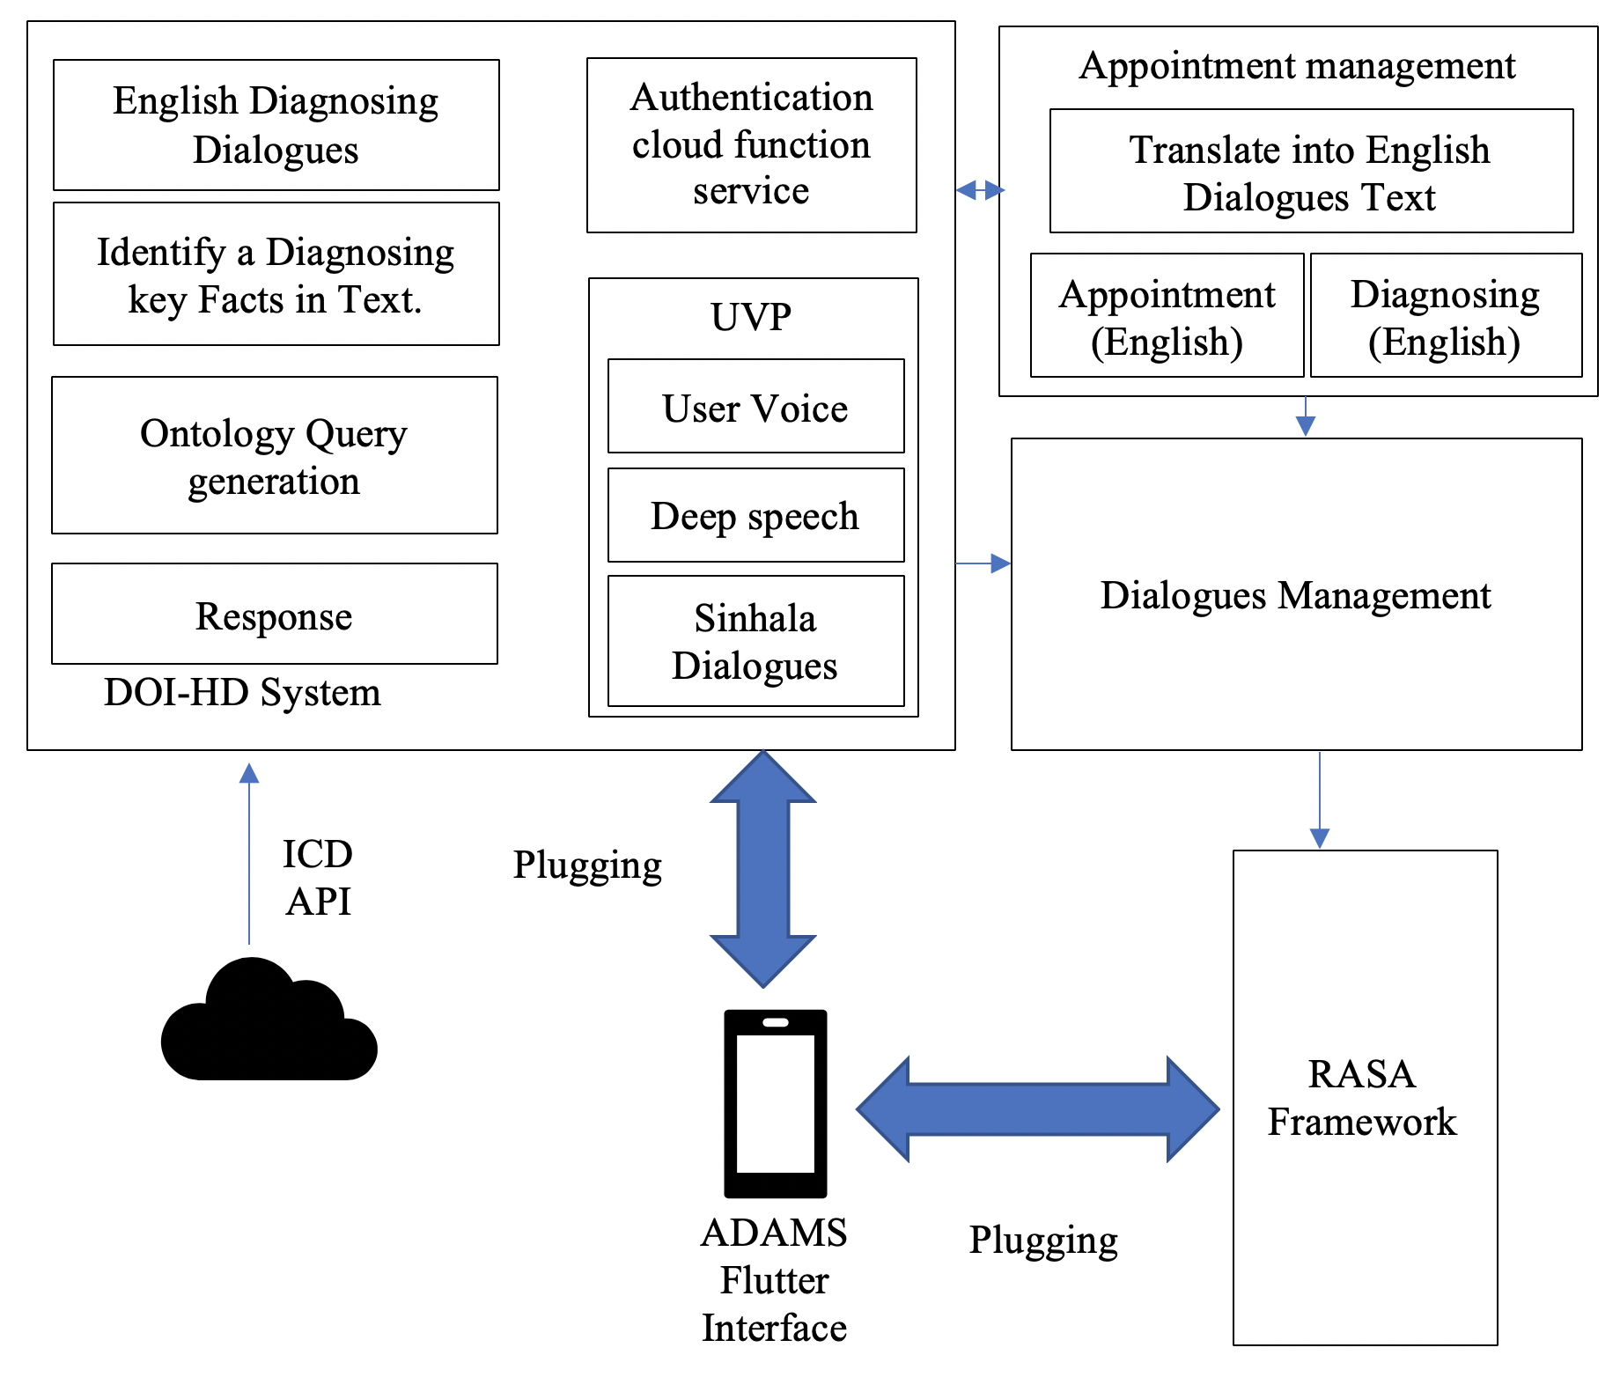

Figure 4.1: High level architecture diagram for DOI-HD

When a user open app user authentication and user session are handled by the Firebase cloud service. therefore, I implement a cloud function. After validation user, he or she can use an ADAMS service. ADAMS only compatible with the Sinhala user's voice and That user's voice converted to Sinhala Text. A specific set of the identified keyword (Medical domain keyword) extracted from a user speech (Sinhala speech Text translate to the English text; it is done by Appointment Management) is compared with a set of identified keywords that are fetched by ICD API. As a fetching data used ontology, using ontology easy to retrieval a domain specified data. Used Owlready Ontology framework and OWL rules. It is a python framework. In our Mobile app interface base on a Flutter framework, it is a platform-independent framework. For that reason, I developed RASA DOI-HD service connection plugging, RASA framework plugging, and Firebase Connection plugging to connecting a Flutter interface. That plugging using can integrate our service into the Flutter interface.

DESCRIPTION OF PERSONAL AND FACILITIES

- Determine the optimum identification to sort out the human diseases (patient is given). -DOI-HD
- Appointments Management
- Dialogue Management
- RASA Framework
This project would be done by a group of four members and the research and development workload of the project is being distributed among all the members. Detailed explanation of the assigned components has been discussed in the previous sections of the document.
Member | Component
D.D.S Rajapakshe | DOI-HD
Kudawithana K.N.B | Appointment Management
U.L.N.P. Uswatte | Dialogue Management
Nishshanka N.A.B.D | Rasa framework

Table 5-1 : Description of personal

PROJECT REQUIREMENTS
Require engineering is a process of establishing
- The services that a customer requires from a system and
- The constraints under which it operates and is developed.

Figure 6.1: Requirements Engineering Process
Two types of Requirements Levels
- User requirements:
- Platform to patient to e-channeling
- Platform to dispensary/ hospital to register their system
- Platform to doctor to register their system

- System requirements:

A structured document setting out detailed descriptions of the system’s functions, services and operational constraints. System requirements are the configuration that a system must have in order for a hardware or software application to run smoothly and efficiently. Failure to meet these requirements can result in installation problems or performance problems. The former may prevent a device or application from getting installed, whereas the latter may cause a product to malfunction or perform below expectation or even to hang or crash. There are two types of System Requirements

- Functional requirements:
Statements of services the system should provide, how the system should react to particular inputs and how the system should behave in particular situations. Describe functionality or system services. Depend on the type of software, expected users and the type of system where the software is used. Functional user requirements may be high-level statements of what the system should do Functional system requirements should describe the system services in detail

- Patient registration to the system
- Patient assistant through the system
- User interact with system using Sinhala voice command
- Doctor appointment for the patients
- Patients can get the information about doctors, hospitals and channeling
- Doctor channeling through the system
- Medical service centers registration to their mobile application

- Non-functional requirements

Constraints on the services or functions offered by the system Often apply to the system as a whole rather than individual features or services. These define system properties and constraints. Non-functional requirements may more critical that functional requirements. If these are not met, the system may be useless.
- Automated conversational mobile application
- The quality of Sinhala Voice commands and the performance like System response time, throughput, utilization, static, volumetric
- Reliability of the system data is the most important fact for both Patients and Medical Service Centres.
- System and its whole functionality (doctor channelling, information accessibility) should be available anytime for the patients.
- How much easier to users when interact with this system’s functionalities
- Total cost for system implementation, developments and use of the services
- How the system localization for Sinhala users with interaction of Sinhala voice commands.

WORK BREAKDOWN STRUCTURE

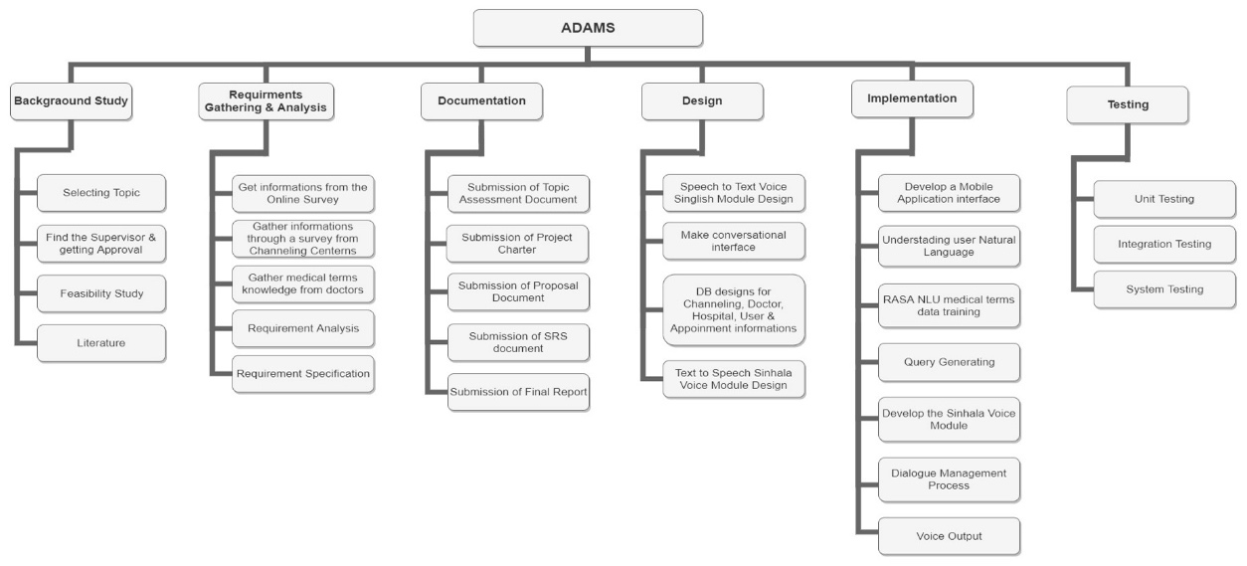
Figure 7.1: Work breakdown structure

BUDGET AND BUDGET JUSTIFICATION

The Budget justification about the ADAMS. These will be the budget that going to estimate in this project. In Research Project is planned to use Firebase Realtime database. Because it’s a mobile compatible database. Firebase has two types of database planning. First one is Spark Plan and the second one is Blaze Plan. Spark Plan is a free plan, but it can’t customize. Then the best plan is Blaze Plan. Because it can customize as the developer wish.
Realtime-Database:1 GB free storage has already been given. But it’s not enough for this project requirements. Then hope to add 4 GB as an extra storage. Then the total storage is 5GB and the price of that storage is $20. 10 GB transferred data has already been given. But another 10 GB data must be added. For that extra 10GB $10 must be paid.
Firebase Cloud Storage:5GB free data has already been provided for the cloud storage. Mainly in this research wants This cloud storage also provides a 5GB free data. This cloud storage also provides us a 5GB free data. Mainly store two voice modules then we want some high capacity storage. Mainly we want to store two voice modules then high capacity storage must be needed. Then 95 GB extra storage must be added. Then total storage capacity is 100 GB. Then $2.47must be paid additionally. 30 GB free storage for data transfer and 2,100,000 operations are provided additionally.
Google Play (Play Store): if this application is used for the Android, a Google Play (Play Store) account must be created. $25 must be paid for this but it is one-time registration payment. MasterCard, Visa, American Express, discover (U.S. only) and Visa Electron (outside of the U.S. only) payment methods will be used in this payment proses.
App Store: If the application is used for the IOS, App Store account must be created. $ 99 must be paid for this but it is annual fee. But If this is an Apple Developer Enterprise Program account, $299 must be paid annually. Some Stationary, Communication and Printing cost are related to this research. These prices can be changed according to the quantity and the value of dollar.

Budget |  | Cost
- Firebase
  - Realtime-Database
- Storage(5GB) | $20
- Transferred data(20GB) | $10 | $30
1.2. Cloud Storage
1.2.1. Storage(100GB) | $2.47 | $2.47
- Total Cost for the Firebase |  | $32.47
- Google Play (Play Store) |  | $25
- App Store |  | $99
- Stationaries (12 months)
- A4 sheets | $1.38
- Rough sheets | $0.55
- Binding | $1.38
- Pens & Pencils | $0.83
- Other Stuff | $1.10 | $5.24
- Communication (12 months)
- Internet service | $13.78
- Phone Cost | $16.54 | $30.32
- Printing Cost (12 months)
- Reports | $2.76
- Photocopy cost | $5.51 | $8.27
Total Cost |  | $200.30

Table 8-1: Budget

TIME PLAN

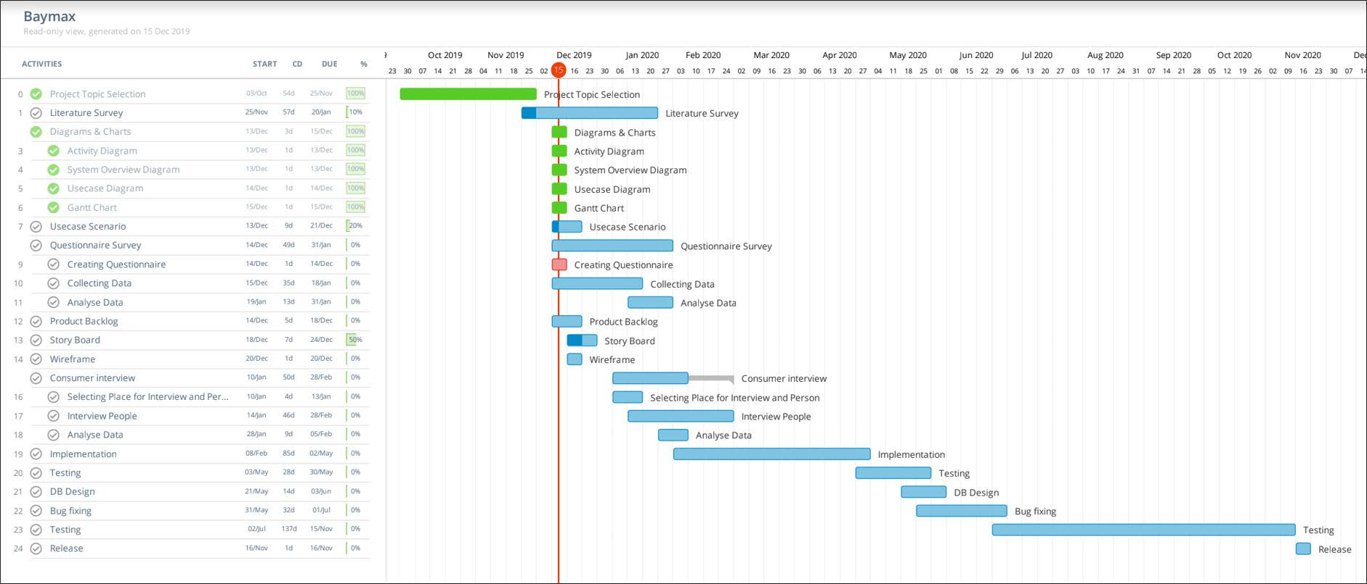
Figure 9.1 : Gantt Chart

https://drive.google.com/open?id=1GXsOwinBr2liyusBCX8MbBiUnvq0dlom
Owlready: Ontology-oriented programming in Python with automatic classiﬁcation and high
level constructs for biomedical ontologies
Owlready: Ontology-oriented programming in Python with automatic classiﬁcation and high
level constructs for biomedical ontologies
Owlready: Ontology-oriented programming in Python with automatic classiﬁcation and high
level constructs for biomedicaREFERENCE

REFERENCES

[1] | E. M. company, “Sri Lanka computer literacy falls amid shift to smartphones, tablets,” 29 January 2019. [Online]. Available: https://economynext.com/sri-lanka-computer-literacy-falls-amid-shift-to-smartphones-tablets-12907/.
[2] | M. Bhatt, “OntoMove: A Knowledge Based Framework for Semantic Requirement Profiling and Resource Acquisition,” 23 April 2007. [Online]. Available: https://ieeexplore.ieee.org/document/4159667.
[3] | C. Wettasinghe, “Sri Lanka computer ownership falls as usage of smartphones, tabs gains,” http://www.dailymirror.lk/article/Sri-Lanka-computer-ownership-falls-as-usage-of-smartphones-tabs-gains--126727.html, 4 April 2017. [Online]. Available: http://www.dailymirror.lk/article/Sri-Lanka-computer-ownership-falls-as-usage-of-smartphones-tabs-gains--126727.html.
[4] | C. BROOK, “What is a Health Information System?,” Digitalguardian, October 2019. [Online]. Available: https://digitalguardian.com/blog/what-health-information-system.
[5] | B. M.-P. &. d. l. T.-D. &. López-Coronado, “Privacy and Security in Mobile Health Apps: A Review and Recommendations,” 20 October 2014. [Online]. Available: https://www.researchgate.net/publication/269289798_Privacy_and_Security_in_Mobile_Health_Apps_A_Review_and_Recommendations.
[6] | W. R. S. P. S. C. W. Mehul Bhatta, “Ontology driven semantic profiling and retrieval in medical information systems,” 8 March 2009. [Online]. Available: https://www.sciencedirect.com/science/article/abs/pii/S1570826809000201. [Accessed 27 May 2009].
[7] | J.-B. Lamya, “Owlready: Ontology-oriented programming in Python with automatic classiﬁcation and highlevel constructs for biomedical ontologies,” August 2017. [Online]. Available: https://www.researchgate.net/publication/319126534_Owlready_Ontology-oriented_programming_in_Python_with_automatic_classification_and_high_level_constructs_for_biomedical_ontologies.
[8] | L. Nachabe, “Applying Ontology to WBAN for mobile application in the context of sport excersises,” September 2014. [Online]. Available: https://www.researchgate.net/publication/267152523_Applying_Ontology_to_WBAN_for_mobile_application_in_the_context_of_sport_excersises.
[9] | O. Bodenreider, “The Unified Medical Language System (UMLS): integrating biomedical terminology,” 1 january 2004. [Online]. Available: https://www.ncbi.nlm.nih.gov/pmc/articles/PMC308795/.
[10] | P. B. S. B. G. N. A. J. N. W. P. C. A. G. A. B. Robert Stevens, “TAMBIS: Transparent Access to Multiple Bioinformatics Information Sources,” ISCB, 1 February 2000. [Online]. Available: https://academic.oup.com/bioinformatics/article/16/2/184/232155.
[11] | T. M. d. Farias, “SWRL rule-selection methodology for ontology interoperability,” 2015 September 2015. [Online]. Available: https://www.researchgate.net/publication/282248747_SWRL_Rule-selection_Methodology_for_Ontology_Interoperability.
[12] | J.-B. LAMY, “Ontology-Oriented Programming for Biomedical Informatics,” IOS Press, 2016. [Online]. Available: https://cmapspublic2.ihmc.us/rid=1Q75R3F5C-TX84TD-XM/2016%20-%20Transforming%20healthcare%20with%20the%20internet%20of%20thing.pdf#page=76.
[13] | T. Nadungodage, “Continuous Sinhala Speech Recognizer,” May 2011. [Online]. Available: https://www.researchgate.net/publication/265992312_Continuous_Sinhala_Speech_Recognizer.
[14] | M. Bali, “Diabot: A Predictive Medical Chatbot using Ensemble Learning,” 2019. [Online]. Available: https://www.academia.edu/39258471/Diabot_A_Predictive_Medical_Chatbot_using_Ensemble_Learning.
[15] | C. Segura, “Chatbol, a chatbot for the Spanish “La Liga”,” May 2018. [Online]. Available: https://www.researchgate.net/publication/327426302_Chatbol_a_chatbot_for_the_Spanish_La_Liga.
[16] | V. V. Sandra V A, “Quinn: Medical Assistant for Mental Counseling using Rasa Stack,” 06 June 2019. [Online]. Available: https://www.irjet.net/archives/V6/i6/IRJET-V6I6297.pdf.
[17] | T. Kowatsch, “Text-based Healthcare Chatbots Supporting Patient and Health Professional Teams: Preliminary Results of a Randomized Controlled Trial on Childhood Obesity,” 2017. [Online]. Available: https://www.alexandria.unisg.ch/252944/2/2368_Kowatsch%20et%20al%202017%20-%20THCB%20PEACH%20Workshop.pdf.
[18] | I. API, “ICD API,” [Online]. Available: https://icd.who.int/icdapi.
[19] | P. Korpipää, “Utilising Context Ontology in Mobile Device Application Personalisation,” january 2004. [Online]. Available: https://www.researchgate.net/publication/221342429_Utilising_Context_Ontology_in_Mobile_Device_Application_Personalisation.
[20] | R. Weerasinghe, “Festival-si: A Sinhala Text-to-Speech System,” September 2017. [Online]. Available: https://www.researchgate.net/publication/221151931_Festival-si_A_Sinhala_Text-to-Speech_System.
[21] | A. Nanayakkara, “A Human Quality Text to Speech System for Sinhala,” August 2018. [Online]. Available: https://www.researchgate.net/publication/328068273_A_Human_Quality_Text_to_Speech_System_for_Sinhala.

